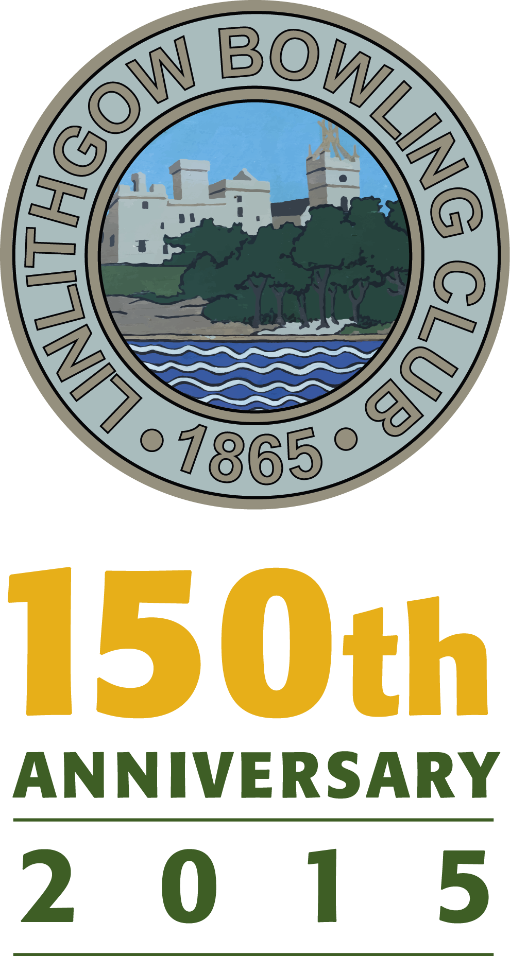

CIVIC RECEPTION TO BE HOSTED BY

WEST LOTHIAN COUNCIL IN THE BURGH HALLS ON FRIDAY 27TH MARCH 2015 AT 7PM

PLEASE ADD YOUR NAME BELOW IF YOU WISH TO ATTEND.

1 12

2 13

3 14

4 15

5 16

6 17

7 18

8 19

9 20

10 21

11 22
23 36

24 37

25 38

26 39

27 40

28 41

29 42

30 43

31 44

32 45

33 46

34 47

35 48

